2) Linux Storage Management
(FDISK + LVM) – Simple Study Material for Teaching

1⃣ Basic Storage Concepts (Very Important for Students)
What is a Disk? lsb
A disk is a physical storage device like:
- Hard Disk (HDD)
- SSD
- Virtual Disk (in VMware / AWS / VirtualBox)
Linux names disks like:
- /dev/sda → First disk
- /dev/sdb → Second disk

Disk → Partition → File System → Mount
Explain this line again and again 👇
Disk → Partition → File System → Mount Point
Example:
/dev/sda → /dev/sda1 → ext4 → /data

2️⃣ Partitioning Basics
What is a Partition?
A partition is a logical piece of a disk.
Example:
- Disk = 100 GB
- Partitions = 50 GB + 50 GB

3️⃣ Partition Types: MBR vs GPT (Theory)
MBR (Old)
- Max disk size: 2 TB
- Max partitions: 4 primary
- Or 3 primary + 1 extended
- Used in old systems
GPT (New)
- Supports very large disks
- Up to 128 partitions
- Used with UEFI
- More reliable
👉 For exams & real servers → GPT is better

4️⃣ File System Types (Explain Simply)
File System | Use
ext4 | Most common Linux FS
xfs | Large data, performance
ntfs | Windows
fat32 | USB (small files)
exfat | USB (large files)

5️⃣ Practical: Disk Detection
Show available disks
Lsblk

Add new disk and use init 6
Detailed disk info
fdisk -l

6️⃣ FDISK – Partition Management
What is fdisk?
fdisk is used to:
- Create partitions
- Delete partitions
- Change partition type

Start fdisk on disk
fdisk /dev/sda

Important fdisk Commands (Must Memorize)
Key | Meaning
p | Show partitions
n | New partition
d | Delete partition
t | Change partition type
w | Save & exit
q | Exit without saving

Create a Partition (Example)
fdisk /dev/sda
Steps inside fdisk:
n → p → partition number → size → w
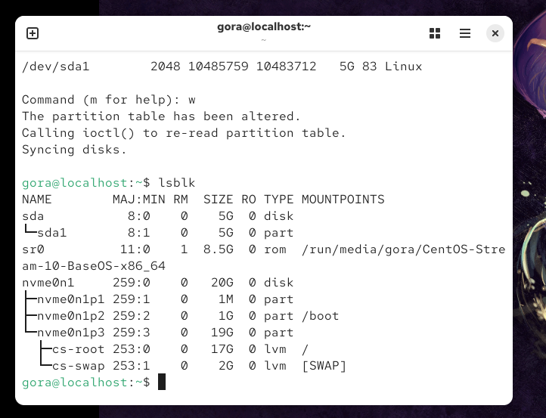

Inform Kernel (No Reboot)
partprobe

gora@localhost:~$ sudo partprobe /dev/sda

7️⃣ Create File System
Create ext4 filesystem
mkfs.ext4 /dev/sda1

8️⃣ Mounting File System
Create mount directory
mkdir /data
Mount partition
mount /dev/sda1 /data
Verify
df -h

9️⃣ Permanent Mount (/etc/fstab)
Open file
vi /etc/fstab
Entry format
/dev/sda1 /data ext4 defaults 0 0

sudo mkdir /data/files
sudo mkdir /data/backup

sudo wipefs -a /dev/sda

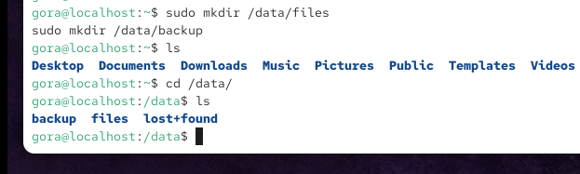

🔟 LVM (Logical Volume Management)
What is LVM? (Simple Words)
LVM allows:
- Resize storage without downtime
- Combine multiple disks
- Flexible disk management

LVM Layers (Golden Concept)
Disk → PV → VG → LV → File System → Mount
Meaning:
Layer | Meaning
PV | Physical Volume
VG | Volume Group
LV | Logical Volume

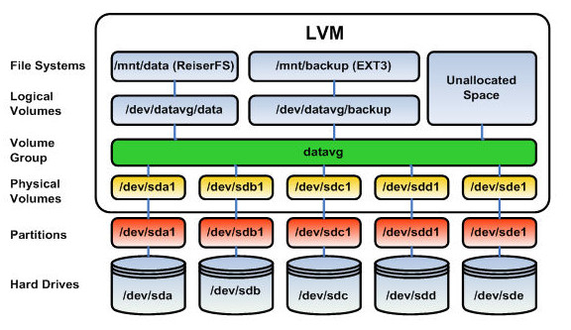

PART 1️⃣ Create LVM using sda1 and sda2

Step 1️⃣ Make sure nothing is mounted
df -h | grep sda
If mounted:
sudo umount /dev/sda1
sudo umount /dev/sda2

Step 2️⃣ Remove any old filesystem (safe)
sudo wipefs -a /dev/sda1
sudo wipefs -a /dev/sdb1

Step 3️⃣ Create Physical Volumes (PV)
sudo pvcreate /dev/sda1 /dev/sdb1
Verify:
sudo pvs

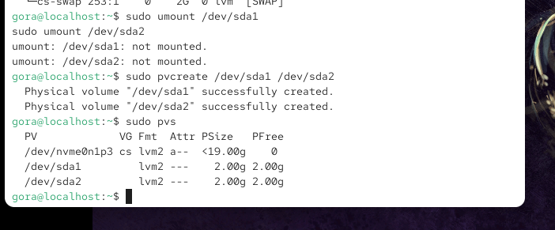

Step 4️⃣ Create Volume Group (VG)
Let’s name it vg_test
sudo vgcreate vg_test /dev/sda1 /dev/sdb1
Verify:
sudo vgs

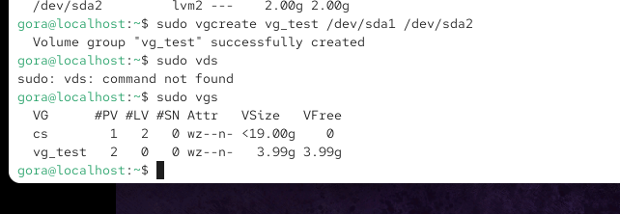

Step 5️⃣ Create Logical Volume (LV)

Create 3 GB LV (not full yet, so we can extend later):

sudo lvcreate –n lv_test -L 5G vg_test

Verify:

sudo lvs

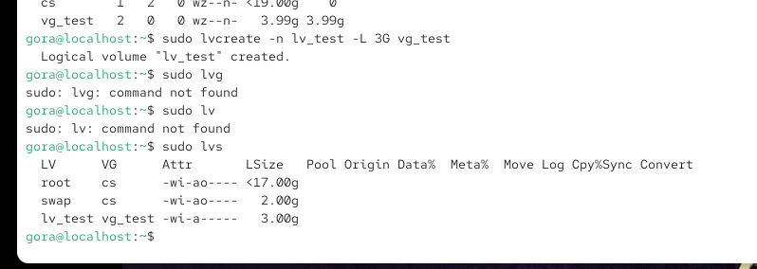

Step 6️⃣ Create filesystem & mount
sudo mkfs.ext4 /dev/vg_test/lv_test
sudo mkdir /mnt/lvmtest
sudo mount /dev/vg_test/lv_test /mnt/lvmtest

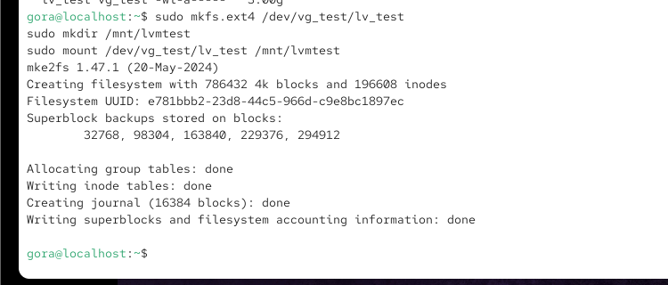
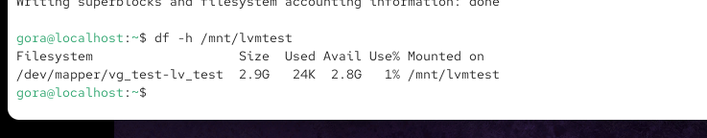

PART 2️⃣ EXTEND LVM (Very important interview topic)
You still have ~1 GB free in VG.

Step 7️⃣ Extend Logical Volume
Extend LV by +1G:
sudo lvextend -L +500M /dev/vg_test/lv_test

Step 8️⃣ Resize filesystem (ONLINE)
Because ext4 supports online resize:
sudo resize2fs /dev/vg_test/lv_test
Verify:
df -h /mnt/lvmtest
LV EXTENDED WITHOUT UNMOUNTING

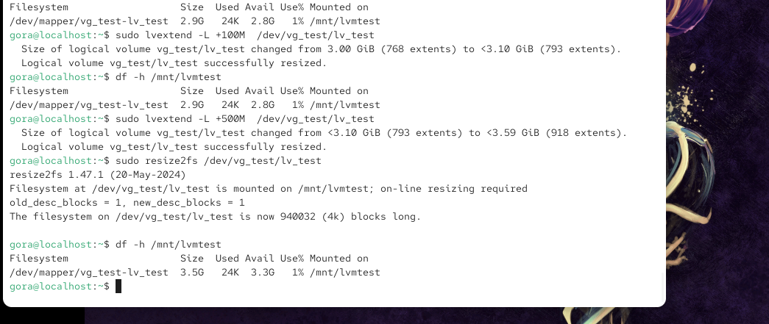

PART 3️⃣ REMOVE / REDUCE LVM (SAFE WAY)
Reducing LV is dangerous if done wrong
Follow steps exactly.

OPTION A️⃣ Reduce Logical Volume

Step 9️⃣ Unmount filesystem
sudo umount /mnt/lvmtest

Step 🔟 Check filesystem
sudo e2fsck -f /dev/vg_test/lv_test

Step 1️⃣1️⃣ Reduce filesystem first
Reduce to 2G:
sudo resize2fs /dev/vg_test/lv_test 3G

Step 1️⃣2️⃣ Reduce Logical Volume
sudo lvreduce -L 3G /dev/vg_test/lv_test

Step 1️⃣3️⃣ Mount again
sudo mount /dev/vg_test/lv_test /mnt/lvmtest
df -h /mnt/lvmtest
✅ LV REDUCED SAFELY

Remove LVM (Cleanup)
sudo umount /mnt/lvmtest
sudo lvremove /dev/vg_test/lv_test
sudo vgremove vg_test
sudo pvremove /dev/sda1 /dev/sdb1

